April 2021
Cheryl Thayer, President
Mary Hope, Vice President
Cindy Del Medico, Treasurer
Linda Berendsen, Secretary
John Bishop, Negotiations & Grievances
Room 2470 DP
Web site: oaktonadjuncts.com
Email: afaoakton@gmail.com
What is the AFA?
It’s your union, protecting and fighting for the rights of all adjuncts covered under the bargaining agreement between the college and the AFA (anyone teaching at least six LHE’s in any of the three previous terms).
Spring 2021 Payroll Dates
Payroll dates for this semester:
April 16, April 30,
May 14 and May 28

Got Questions or Comments
for the AFA?
Next AFA ‘Office Hours’ are available on Zoom on Friday, May 7, from 9 to 10 a.m. A link will be sent via email closer to the date. The next AFA Board meeting is Friday May 21 at 10. You are welcome to come!
Condolences
to Jody Lepinot,
Art Department instructor, whose mother has recently passed away.

We need your survey!
(AFA Contract Negotiations Are Beginning)
YouThe AFA negotiating team is meeting with the administration for the first time on April 16. They are negotiating on behalf of all of you in the bargaining unit (anyone teaching at least six LHE’s iin any of the previous three terms). But just what are they negotiating for? Well, you need to tell them.
oW We have all received a survey in our email on just what our concerns are about teaching at Oakton. It is clear, well-organized and takes about 10 minutes to complete – maybe less. The negotiating team needs to know what your concerns are so that they can negotiate for those. Tell them!
less
Get involved and get Paid
Did you know that you are paid for serving in a college-wide committee? You can also participate in decisions that are made throughout the college in hiring, diversity initiatives, curricula, and so on. Participating is easier than ever when meetings are on Zoom. Names are being collected now. Email the AFA at afaoakton@gmail.com.

Newsflash! Danger
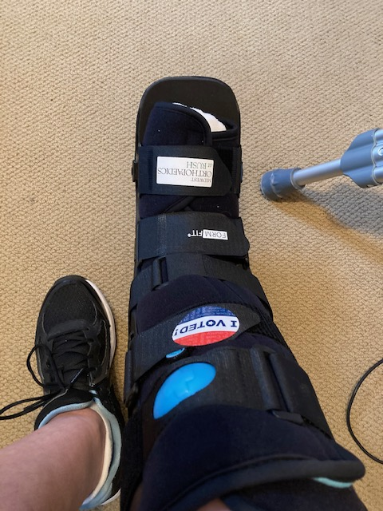
Found From Prolonged Zooming!
Remember, you heard it here first! One of our fellow adjuncts, who desires to remain anonymous, reported a Zoom related injury this past week. While on Zoom for 3 hours, her legs fell asleep, as they are wont to do. Getting up from said position, legs asleep, and attempting to walk, she found herself on the floor, and is now hobbling about on crutches with a large boot, the result of a broken foot and sprained ankle. Crutches 2 weeks; boot 8 weeks. Let this be a lesson….


The courtyard
at the Des Plaines campus mid-April

