August 2021
Cheryl Thayer, President
Mary Hope Griffin, Vice President
Cindy Del Medico, Treasurer
Linda Berendsen, Secretary
John Bishop, Negotiations & Grievances
Room 2470 DP
Web site: oaktonadjuncts.com
Email: afaoakton@gmail.com

What is the AFA?
It’s your union, protecting and fighting for the rights of all adjuncts covered under the bargaining agreement between the college and the AFA (anyone teaching at least six LHE’s in any of the three previous terms).

Fall 2021 Payroll Dates
Payroll dates for this semester:
Sept. 3, 17; Oct. 1, 15, 29
Nov. 12, 26; Dec. 10, 24
Dues are taken from
the 5th and 6th paychecks.
Welcome
New AFA Members!
Elizabeth Sanderson, Library
Kathleen Pacyna, Sociology

Oakton Board of Trustees meetings:
Aug 17, Sept. 21, Oct. 19, Nov. 16, Dec. 14
7:30 p.m.

Welcome back!
Welcome back to all of you seasoned remote teachers!

The AFA team has been hard at work all summer negotiating the new AFA contract with the administration. Each of the five AFA team members have put in over 130 hours on the contract negotiations. Your team members are Cheryl Thayer, John Bishop, Mary Hope Griffin, Nelson Wainwright, and Ruth Whitney. While our current contract expires on August 22, it will continue to be in force until the new contract is voted on, ratified by the membership, and approved by the Board of Trustees. Negotiations might continue another two or three months. To give you an idea, our current contract was approved by the Board of Trustees at their Dec. 5, 2017 meeting. Of course, any pay raises in the new contract will be retroactive from the starting date, August 23.

Updates from the August 18 AFA Membership Meeting
- There have been problems with the Duo Factor Authorization process. If you have had a problem with, report them to the AFA; the administration has been responsive about this. If you have had to purchase a new smart phone or device because of the Duo Factor Authorization process, this should be reported to the union.

- If you have had issues with payroll, enrollment, or reassignment issues, report it to the AFA as these are contractual issues.

- If you are unsure of your AFA membership status, email the AFA and it will be checked. The contract needs to ratified by the members, and only members can vote.

- Regarding office space, although there will be some permanent work stations, there will also be some ‘hoteling.’ The college is encouraging office hours or meetings with students to be done remotely. You can also see students in the classroom during the half hour after class. If a permanent work station is needed, contact the college.

- None of the computers on campus have cameras or microphones; the AFA is asking the college to solve this problem. Most classrooms are equipped with hi-flex cameras.

- The AFA is always looking for adjuncts to serve on college wide or search committees. When there are openings, they will be posted. These are paid and ensure that the voices of adjuncts are heard. Contact the AFA at afaoakton@gmail.com. These are compensated for.
Best wishes to Retirees
Karen Greenberger, who taught psychology and who served on various committees
Samuel Kleineman, who taught math
Karen Roth, who taught in ECE and was the
go-to person for service learning at Oakton

George Sanvanson, who taught Chemistry

- There will be a photo contest for the AFA website of photos of the adjunct experience.

- Elections for representatives to the next IEA assembly in Rosemont will be held; nominations are needed. The software used in the last election will be used. The NEA RA will be held in Dallas this coming year.

- A motion was passed at the meeting to give a $1000 stipend from AFA funds to each of the five adjuncts on the negotiating team to compensate for the 130 hours of work each has done on the negotiations so far.

- Both AFA President Cheryl Thayer and Vice President Mary Hope Griffin will be on the Des Plaines campus on Mondays and Wednesdays this semester if you need to talk with one of them.
Yes, Enrollment is Down. What About My Class?
Enrollment is down about 15%. If your class enrollment is below 10, keep monitoring the enrollment numbers on Banner and if the number goes up, keep a screenshot as proof. You will be paid on the basis of the highest enrollment. See Section 2.6 and 2.7 of our contract (see https://oaktonadjuncts.com/afa-occ-contract) for course cancellation and reassignment payment for canceled and reassigned courses.

What Happened to Oakton’s Name Change?
According to an August 20 Daily Herald article, during the August 17 Board of Trustees meeting, six of eight trustees voted to change the public name of the college to Oakton College. Neither the date to begin use of the new name nor the cost of changing the name of buildings, signs, websites, promotional materials, etc. is not set yet. Oakton spokesperson Steve Butera said “The Board’s discussion centered on the college’s identity moving into its next 50 years.” Trustee Benjamin Salzburg felt that some students may be put off from coming to Oakton by the word “Community” and the “stigma and perception” about community colleges.

Trustee Bill Stafford voted against the name change citing cost concerns, as did Student Trustee Akash Patel, whose vote is advisory.


Congratulations
Kate Magnason was hired by the English Department to be its new full-time ESL instructor. Kate and her husband also welcomed twin sons to their family this month! Mom and babies are doing well.

Olabisi Adenekan was also hired as the new full-time instructor in Developmental English. Olabesi has also just received her PhD.

Both Kate and Olabisi were long-time adjuncts in English; it is great news that their accomplishments are recognized!!
This Photo by Unknown Author is licensed
CC BY-NC-ND

Congratulations to Christopher Bower for winning this year’s
Ray Harstein Award for Teaching Excellence. Christopher teaches English in the Liberal Arts Department.

TIAA Study on Adjuncts
An article in the July 23 issue of Inside Higher Ed summarized a TIAA Institute paper on adjuncts. 40 adjuncts who taught in a range of institutions were interviewed. While some who
had a “day job” outside of teaching had savings plans and health care, those who did not have this source of income and worked at multiple institutions said they were interested in having “matching benefit plans across all employing institutions,” in other words, having a “centralized savings system” that would be convenient to use even if one changed institutions. The catch found was that if adjuncts rely on their teaching as a primary source of income, they don’t have enough cash to spare to invest in a savings plan, even if ‘free money’ in the form of matching contributions are made. The study recommends that it is this group of adjuncts that institutions should keep in mind when crafting retirement plans for their instructors. As many of us know, retirement is a huge issue for many adjuncts. (This study was done pre-pandemic.) Maria Maisto, president of the New Faculty Majority, an advocacy organization for adjuncts, stated that adjuncts’ situation is “a continuing reflection of how misinformed people are about the practical realities of contingent faculty employment practices” and that ”systems like retirement and unemployment were not designed for contingent workers, as if contingent workers did not have a need for them. They couldn’t be more wrong.” This brings to mind our own annuitant fiasco from several years ago when retirement plans of many adjuncts went up in smoke. The full article can be read at https://www.insidehighered.com/news/2021/06/23/papers-urge-institutions-think-about-adjuncts-including-terms-retirement.

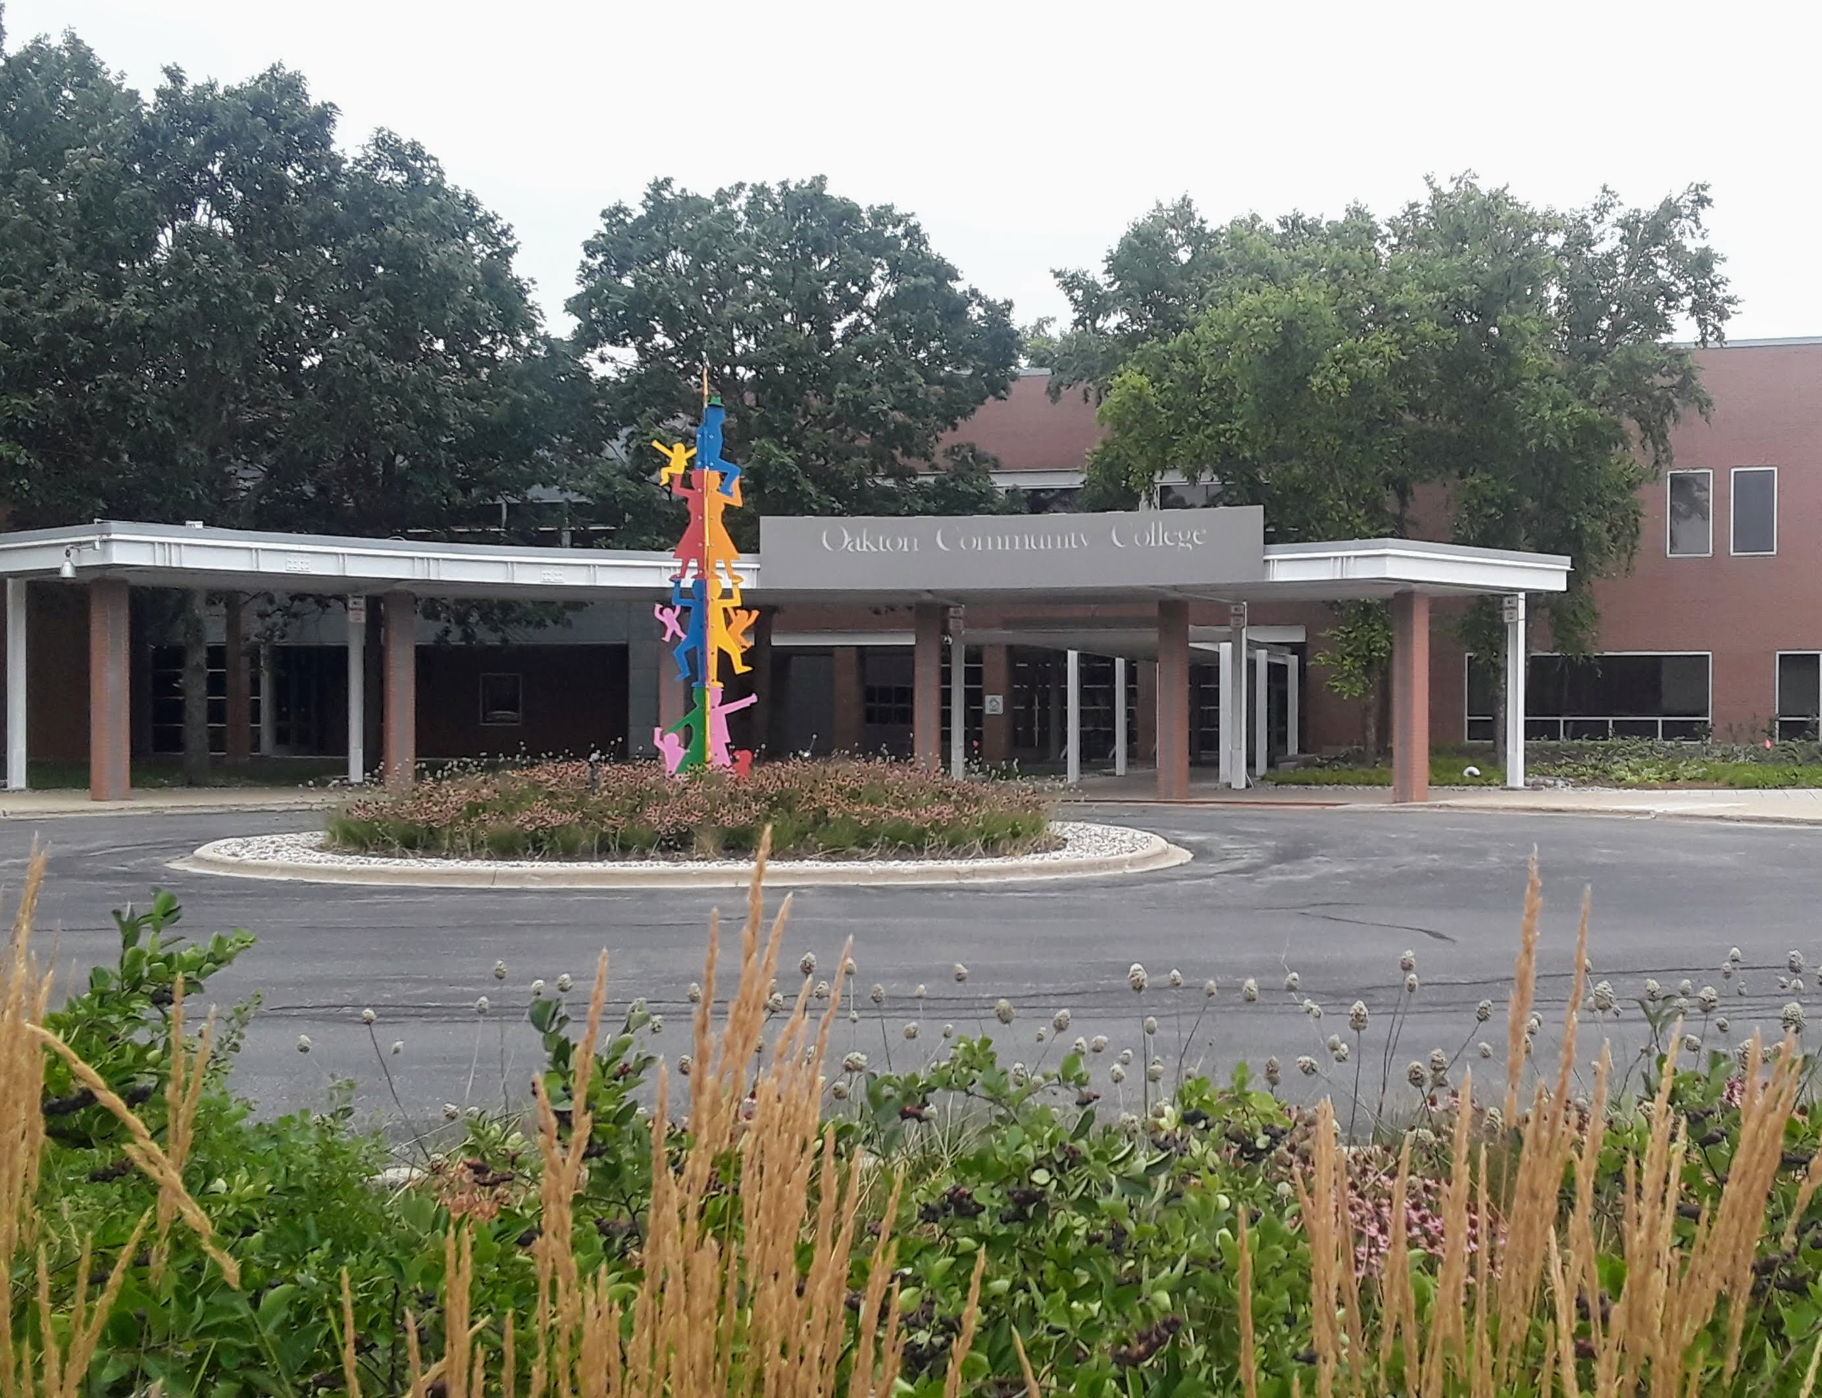
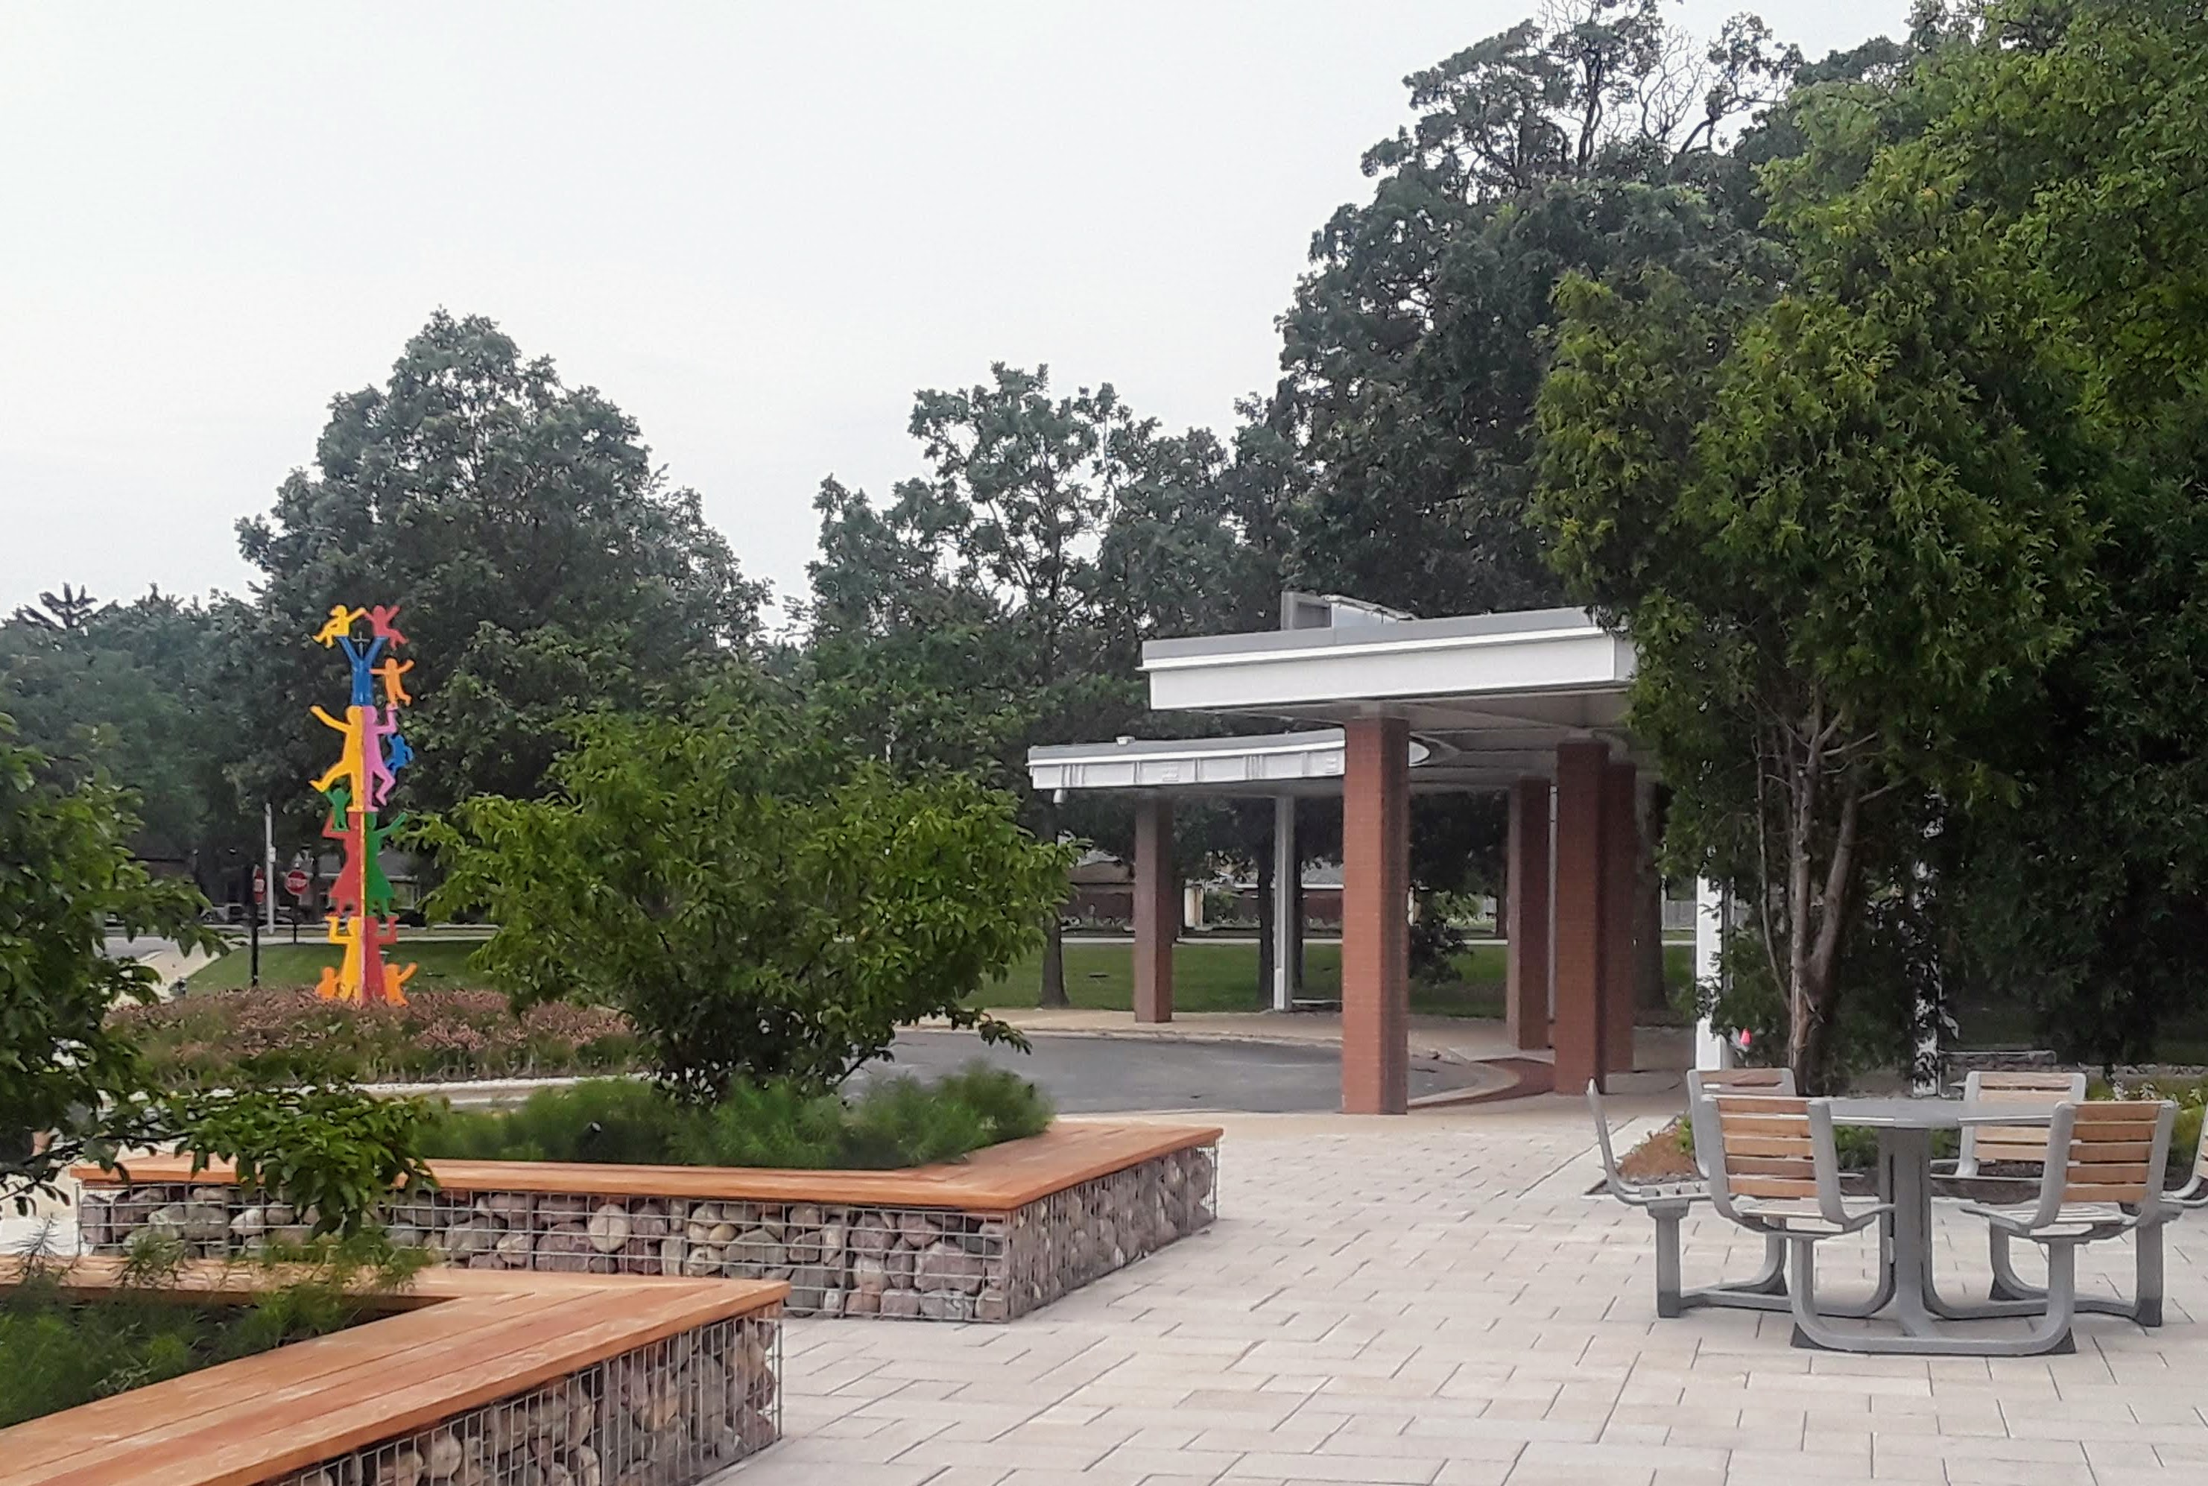
New look at the Ray Harstein Skokie campus

Trying to get your steps in?

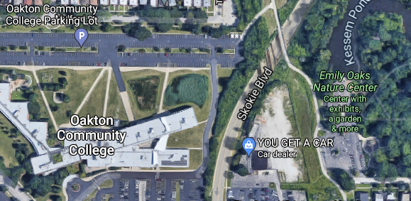
Oakton’s Des Plaines campus has a pond, a prairie and woods galore, and Skokie has….Emily Oaks Nature Center, a hidden gem. The Nature Center building and trails around the pond and through the woods are just a short walk from the north parking lot, across a pedestrian bridge over Skokie Blvd to the entrance to the park.

And How was YOUR Summer?
Wouldn’t you love to know how your colleagues have been? They would like to know about you too. Could you pen 150 words or so and tell us about YOUR summer?
For example,

My husband I were finally able to use last years’ tickets to the Oregon coast. So ALIVE - things growing everywhere. I just hope these starfish and anenome did not bake in summer’s high temperatures. Back home, I did my best to focus on teaching an on-line course, which I finished as did (most of) the students. An on-line art course – and the full re-opening of the Skokie Library - kept me sane. I am immensely proud of my Japanese cucumbers and 2 cataloupe (still growing) and am looking forward to trying Chinese brocolli in the fall garden.
See? Short and sweet. Please sent to Lberends@oakton.edu. You (and your colleagues) will be glad that you did.

