January 2022
Cheryl Thayer, President
Mary Hope, Vice President
Cindy Del Medico, Treasurer
Linda Berendsen, Secretary
John Bishop, Negotiations & Grievances
Room 2470 DP
Web site: oaktonadjuncts.com
Email: afaoakton@gmail.com

What is the AFA?
It’s your union, protecting and fighting for the rights of all adjuncts covered under the bargaining agreement between the college and the AFA (anyone teaching at least six LHE’s in any of the three previous terms).

Spring 2022 Payroll Dates
Feb. 4 and 18,
March 4 and 18,
April 1, 15, and 29,
May 13 and 27
OCC Board of Trustee Meetings:
7:30 p.m. on
Jan. 18, Feb. 15, March 15, April 26, May 24, June 28.

Welcome to Spring 2022
The team is still in the midst of negotiations, but it is expected that the new contract with the college will be ready during the end of January or beginning of February. Town halls will follow to communicate with the membership the details of the contract, followed by a vote by the membership on whether to accept it or not.

Several dozen adjuncts attended both the OCCFA (the Oakton Community College Faculty Association) Spring Orientation week meeting as well as the AFA (the Adjunct Faculty Association) Membership meeting. There was much discussion and many questions regarding the beginning of Spring semester in light of the Omicron surge. The AFA had asked the administration to shift face to face classes to remote during the first two weeks of the semester while OCCFA had asked for classes up until spring break to go on-line. At that point, we learned that the college administration had refused both requests. Many faculty voiced concern over their own health and the health of family members if classes met face to face. Many other major universities in the Chicago area had already announced a temporary switch to remote learning.

Of course, we know now that the administration has decided to pivot to remote learning for most classes for these first 2 weeks of the semester. What brought about this change of mind? The combined voices of faculty in the full-time and part-time unions. No one person can negotiate their own pay raise or change in policy or being able to take free classes or being able to take sick leave amounting to 20% of one’s course. But our two faculty unions can speak for us.

If you are not a member of the AFA yet – and want to vote on the new contract that will be finished shortly, go to the AFA website (oaktonadjuncts.com) and sign up.


About Spring Classes
- Faculty teaching in-person classes can verify whether or not their students are in compliance with the state of Illinois mandate to be either vaccinated against the Covid virus or to be tested weekly for infection. When a student in your in-person class opens their myOakton page, their status will be visible. For privacy reasons, it is recommended that this be checked (if you wish) outside the classroom.

- If a student refuses to wear a mask in your classroom or is not in compliance, faculty have the right to refuse admission to your classroom. In a case of non-compliance, tell the office of Student Affairs. In a second instance of non-compliance for that same student, again tell Student Affairs; that student will then be “disenrolled” from Oakton.
- Office hours can be held remotely.
- Most classrooms have cameras that were installed for ’hyper-flex’ classes. Using these cameras to record your in-person classes would enable students who cannot come to still be in class.
- In light of the pandemic, many faculty are opting to not make in-person attendance part of students’ grades.
- See the attachments in the January 12 email from OCCFA’s Suzie Ziegenhorn for more information on Covid and the classroom.

Questions about How to Get the Best out of D2L?
Here are the January and February sessions being offered virtually by CPD on using elements of D2L:

Assignments & Discussions: Feb. 3, Thursday, 9-10 a.m.
Attendance: Feb. 9, Wednesday, 1-2 p.m.
Checklist: Feb. 16, Wednesday, 1-2 p.m.
Course Content: Jan. 18, Tuesday, 10-11
Jan. 20, Thursday, 2-3 p.m.
Groups: Feb. 17, Thursday, 11-12
Honorlock: Feb. 4, Friday, 10-11
Quizzes/Exams: Jan. 27, Thursday, 11-12
Feb. 3, Thursday, 11-12
Rubrics: Feb. 23, Wednesday, 1-2
Tracking student progress: Feb. 2, Wednesday, 1-2
Video Note: Jan. 31, , Monday, 5-6

There are also Q&A sessions related to D2L tools, features and the tools integrated into D2L such as TurnItIn, Honorlock, and Big Blue Button:
January 28, Friday, 1-2
February 25, Friday, 12-1

All of the above require registration through CPD.

The 12-LHE Project Available
Again this year, a pool of 12 LHEs is available for projects that support student success. These initiatives are eligible for consideration:

- Integrate a high impact practice into course content and activities (that reduces opportunity gaps and encourages success for all students; e.g., service learning, problem-based learning, community-based project).
- Develop and lead a project that increases adjunct faculty engagement and inclusion within a discipline, department, division, or college-wide.
- Develop and deliver open educational resource materials (OER).

- Lead a student success initiative within a discipline, department, and/or division (e.g. pre-major/pathways development or major revision, organizing co-curricular events).
- Develop content-specific online course materials or interactive student activities that can be shared with faculty within a department/program (persons that received LHEs to develop these materials as part of an online course would not be eligible).
- Research, using data from an Office of Institutional Research request, any learning equity gaps in the courses you teach and develop and implement an action plan to address those gaps.

Applications are due by Tuesday, February 15, 2021 by 5p.m. and can begin in summer 2022. Applicants need the approval of one’s chairperson/coordinator and dean before submitting the application.

Typically, applicants ask for .5, 1 or 2 LHE’s, depending on the scope of the project. Has your class been ‘shambled”? We all put a lot of work into our courses and this might be a project that you can use yourself in the future. Contact Ruth Williams (rwilliams@oakton.edu) or Cheryl Thayer (cthayer@oakton.edu) for a rubric to follow as you plan your project and the application.

You Can Learn and Get Paid …
For attending these seminars being offered this semester by the CPD:
- Creating an Equity-Minded Syllabus, presented by Eva de la Riva Lopez and Kristen Hren and meeting synchronously on-line eight Thursday afternoons, Jan. 27 to May 5, from 2 to 4 p.m.
- Desire2Learn Bootcamp, presented by Danielle Dickerson and Kayla Mitchell, meeting synchronously on-line for eight Friday afternoons from 1:00-3:00 from Feb. 4 to April 1.
- Supporting AAPI Students: Getting Started. This on-line synchronous seminar on Asian American and Pacific Islander students is being presented by Dear Aunaetitrakul and Mohamed Mehdi, meeting on four Tuesdays, from 2:15 to 4:45 p.m. from March 8 to April 19.

Pritzker Wants to Veto House Bill 2778; Tell Him to Sign It.
This Wage Protection Bill would require that districts provide COVID administrative days to any school or college employees to be used for all COVID related absences such as quarantining and testing as well as provide paycheck protection for hourly employees so that they would still receive their full paycheck if the school needs to close due to any COVID-related reason. Go to ieanea.org for an easy form to fill out. It has already overwhelmingly passed out of the House and Senate; however, Pritzker intends to veto the proposal. See p. 4 of the Jan. 16 Chicago Tribune for more information.
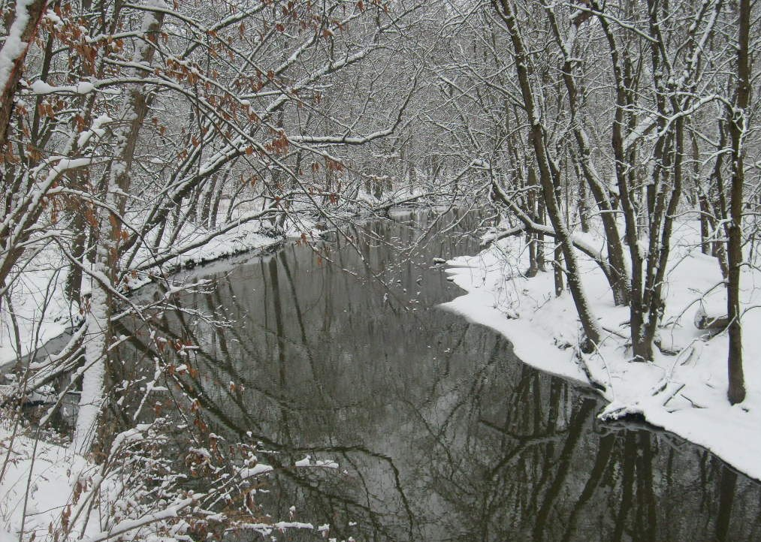
Photo Contest!
There is still time to participate in the AFA’s photo contest! Several submissions have been already received – share yours! The topic: Adjunct Life. Photos taken on any device are welcome, and three $25 gift cards will be awarded. Use your imagination! Your photo will appear on our website. The deadline is Feb. 28; go to the AFA website oaktonadjuncts.com.

Do you have news to share with us? Please send an email to Laberendsen@gmail.com

